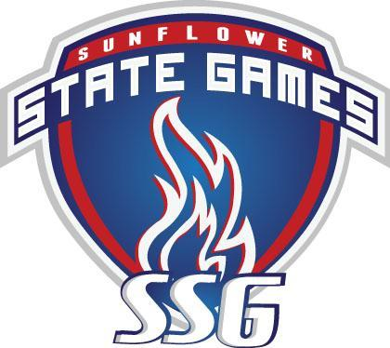

Orienteering
13-July-2025 at Gage Park

Link to Livelox to view time charts and routes
Link to WinSplits to see more details on the splits
Photos by Gene Wee

DIVISION: Long Course - Female (under 60)
Place: | Name: | Hometown: | Time:
Gold: | Carrie Hodges | Lawrence KS | 0:24:26
Silver: | Lisa Grossman | Lawrence KS | 0:30:32
Bronze: | Anna Noonoo | Topeka KS | 0:33:17

DIVISION: Long Course - Female (61 and up)
Place: | Name: | Hometown: | Time:
Gold: | Mary Jones | Lawrence KS | 0:27:54
Silver: | Angela Candela | Lawrence KS | 0:43:48
Bronze: | Janet Majure | Lawrence KS | 0:50:00
4 | Mary Eyen | Leawood KS | 0:57:03

DIVISION: Long Course - Male under 60)
Place: | Name: | Hometown: | Time:
Gold: | Christian Nord | Overland Park KS | 0:20:10
Silver: | Paulo Sousa | Fort Leavenworth KS | 0:20:16
Bronze: | Scott Neuburger | Kansas City MO | 0:21:31
4 | Bill Schluben | Overland Park KS | 0:21:38
5 | Carson Hirst | Topeka KS | 0:29:12
6 | Blair Sutton | Lawrence KS | 0:32:05
7 | Spencer Eyen | Leawood KS | 0:56:50

DIVISION: Long Course - Male (61 and up)
Place: | Name: | Hometown: | Time:
Gold: | Michael Eglinski | Lawrence KS | 0:25:40
Silver: | Daniel Hodges | Lawrence KS | 0:25:42
Bronze: | Gene Wee | Lawrence KS | 0:27:48
4 | David Kough | Lawrence KS | 0:29:21
5 | George Pogge | Lawrence KS | 0:35:28
6 | Richard Neuburger | Lenexa KS | 0:42:28
7 | Pat Slusher | Liberty MO | 0:42:50
8 | Tom Eyen | Leawood KS | 0:57:08
9 | Rick Hermesch | Lawrence KS | 0:33:00 (MP)

DIVISION: Long Course - Team
Place: | Name: | Hometown: | Time:
Gold: | Anaiah Covey and Payton Tryhus | Topeka KS | 0:30:58
Silver: | Bryn Deering and Isabelle Smith | Topeka KS | 0:43:21
Bronze: | Marlee and Thad Carpenter | Topeka KS | 0:43:24
4 | Sophia Morales and Hannah Windholz | Ozawkie KS | 0:54:53

DIVISION: Short Course - Female
Place: | Name: | Hometown: | Time:
Gold: | Laura Sousa | Fort Leavenworth KS | 0:26:08

DIVISION: Short Course - Male
Place: | Name: | Hometown: | Time:
Gold: | Reed Deering | Topeka KS | 0:25:42
Silver | Mike Shifman | Overland Park KS | 0:44:22
Bronze: | Walt Menninger | Topeka KS | DNF

DIVISION: Short Course - Team
Place: | Name: | Hometown: | Time:
Gold: | Avi and Jeremy Sander | Overland Park KS | 0:10:58
Silver: | Allison and Elaine Seeman | Lawrence KS | 0:50:04
Bronze: | Olivia Smith and Macy Sorensen | Topeka KS | 1:00:05

