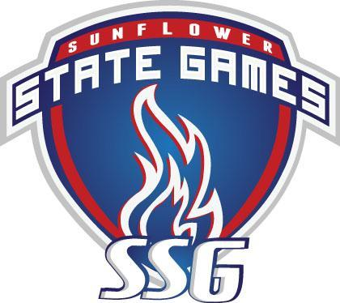

**Orienteering**

**13-July-2025 at Gage Park**

**Link to** [**Livelox**](https://www.livelox.com/Events/Show/162596/Sunflower-State-Games-2025) **to view time charts and routes**

**Link to** [**WinSplits**](https://obasen.orientering.se/winsplits/online/en/show_event.asp?id=106404) **to see more details on the splits**

[**Photos**](https://www.flickr.com/photos/ngungilson/albums/72177720327518367/) **by Gene Wee**

**DIVISION: Long Course - Female (under 60)**

|  |  |  |  |
| --- | --- | --- | --- |
| **Place:** | **Name:** | **Hometown:** | **Time:** |
| Gold: | Carrie Hodges | Lawrence KS | 0:24:26 |
| Silver: | Lisa Grossman | Lawrence KS | 0:30:32 |
| Bronze: | Anna Noonoo | Topeka KS | 0:33:17 |

**DIVISION: Long Course - Female (61 and up)**

|  |  |  |  |
| --- | --- | --- | --- |
| **Place:** | **Name:** | **Hometown:** | **Time:** |
| Gold: | Mary Jones | Lawrence KS | 0:27:54 |
| Silver: | Angela Candela | Lawrence KS | 0:43:48 |
| Bronze: | Janet Majure | Lawrence KS | 0:50:00 |
| 4 | Mary Eyen | Leawood KS | 0:57:03 |

**DIVISION: Long Course - Male under 60)**

|  |  |  |  |
| --- | --- | --- | --- |
| **Place:** | **Name:** | **Hometown:** | **Time:** |
| Gold: | Christian Nord | Overland Park KS | 0:20:10 |
| Silver: | Paulo Sousa | Fort Leavenworth KS | 0:20:16 |
| Bronze: | Scott Neuburger | Kansas City MO | 0:21:31 |
| 4 | Bill Schluben | Overland Park KS | 0:21:38 |
| 5 | Carson Hirst | Topeka KS | 0:29:12 |
| 6 | Blair Sutton | Lawrence KS | 0:32:05 |
| 7 | Spencer Eyen | Leawood KS | 0:56:50 |

**DIVISION: Long Course - Male (61 and up)**

|  |  |  |  |
| --- | --- | --- | --- |
| **Place:** | **Name:** | **Hometown:** | **Time:** |
| Gold: | Michael Eglinski | Lawrence KS | 0:25:40 |
| Silver: | Daniel Hodges | Lawrence KS | 0:25:42 |
| Bronze: | Gene Wee | Lawrence KS | 0:27:48 |
| 4 | David Kough | Lawrence KS | 0:29:21 |
| 5 | George Pogge | Lawrence KS | 0:35:28 |
| 6 | Richard Neuburger | Lenexa KS | 0:42:28 |
| 7 | Pat Slusher | Liberty MO | 0:42:50 |
| 8 | Tom Eyen | Leawood KS | 0:57:08 |
| 9 | Rick Hermesch | Lawrence KS | 0:33:00 (MP) |

**DIVISION: Long Course - Team**

|  |  |  |  |
| --- | --- | --- | --- |
| **Place:** | **Name:** | **Hometown:** | **Time:** |
| Gold: | Anaiah Covey and Payton Tryhus | Topeka KS | 0:30:58 |
| Silver: | Bryn Deering and Isabelle Smith | Topeka KS | 0:43:21 |
| Bronze: | Marlee and Thad Carpenter | Topeka KS | 0:43:24 |
| 4 | Sophia Morales and Hannah Windholz | Ozawkie KS | 0:54:53 |

**DIVISION: Short Course - Female**

|  |  |  |  |
| --- | --- | --- | --- |
| **Place:** | **Name:** | **Hometown:** | **Time:** |
| Gold: | Laura Sousa | Fort Leavenworth KS | 0:26:08 |

**DIVISION: Short Course - Male**

|  |  |  |  |
| --- | --- | --- | --- |
| **Place:** | **Name:** | **Hometown:** | **Time:** |
| Gold: | Reed Deering | Topeka KS | 0:25:42 |
| Silver | Mike Shifman | Overland Park KS | 0:44:22 |
| Bronze: | Walt Menninger | Topeka KS | DNF |

**DIVISION: Short Course - Team**

|  |  |  |  |
| --- | --- | --- | --- |
| **Place:** | **Name:** | **Hometown:** | **Time:** |
| Gold: | Avi and Jeremy Sander | Overland Park KS | 0:10:58 |
| Silver: | Allison and Elaine Seeman | Lawrence KS | 0:50:04 |
| Bronze: | Olivia Smith and Macy Sorensen | Topeka KS | 1:00:05 |