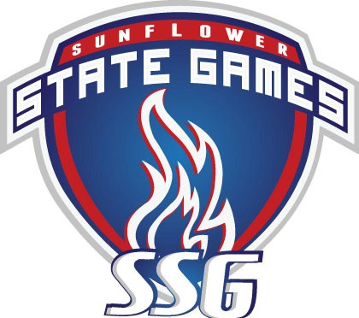

SSG Volunteer Form

# PLEASE NOTE: For insurance purposes, this form must be completely filled out by all volunteers prior to engaging in any activity related to the Sunfl0wer State Games. Upon comple- tion, please submit this form to the Sport Commissioner or the Volunteer Coordinator.

Name: (First) (Last)_

Mailing Address:

City:

State:

Zip:

Day Phone: - - Evening Phone

PERSONAL INFORMATION

Birthdate: / /

Age:

Gender: M / F

Email Address:

T-Shirt Size: YL S M L XL 2XL 3XL

Emergency Contact Name & Phone:

Sport:

*How did you hear about volunteering for the Sunflower State Games?*

*If you are volunteering for a business or sponsor, please list the business name below:*

IMPORTANT: All volunteers must review and sign the waiver form on the back of this sheet.

Volunteers under the age of 18 must have a parent or guardian’s signature.

*Please note that all volunteers under the age of 16 must be accompanied by an adult.*

Your assistance is greatly appreciated. The Sunflower State Games would not be possible without your help in performing volunteer duties. Prior to your volunteer event date, please confirm your volunteer assignment and sched- ule with the Volunteer Coordinator of your sport. On event day, please check-in on site with your Volunteer Coordinator to obtain your volunteer T-shirt and duties. We look forward to having you on our team and THANK YOU for your service to SSG!

VOLUNTEER NOTES

COMMISSIONERS / VOLUNTEERS

Please submit completed forms to the Sunflower State Games: 501 SE Jefferson, Suite 22, Topeka, KS 66607

Email: [admin@sunflowergames.com](mailto:admin@sunflowergames.com)

Sunflower State Games Volunteer Waiver

This document is important, must be read in its entirety and signed before any volunteer is allowed to participate.

**Printed Name Sport**

MANDATORY WAIVER: In consideration of being allowed to participate in, or assisting others in participating in the Sunflower State Games athletic program, its related events and activities, the undersigned acknowledge, appreciate, and agree that:

1. The risk of injury from the activities involved in this program is significant, including the potential for permanent paralysis and death, and while particular rules, equipment, and personal discipline may reduce this risk, the risk of serious injury does exist; and,
2. I KNOWINGLY AND FREELY ASSUME ALL SUCH RISKS, both known and unknown, EVEN IF ARISING FROM THE NEGLIGENCE OF THE RELEASEES or others, and assume full responsibility for my participation; and,
3. I willingly agree to comply with the stated and customary terms and conditions for participation. If, however, I observe any unusual significant hazard during my presence or participation, I will remove myself from participation and bring such to the attention of the nearest official immediately; and,
4. I hereby consent to allow my picture and/or voice or likeness to appear in any official documentary, promotional, exclusive television, radio or film coverage of the Sunflower State Games in any manner incidental to my participation in the Sunflower State Games and without compensation to me; and,
5. I, for myself, and on behalf of my heirs, assigns personal representatives and next of kin, HEREBY RELEASE AND HOLD HARMLESS the Sunflower State Games, their officers, officials, agents and/or employees, other participants, sponsoring agencies, sponsors, advertisers, and, if applicable, owners and lessors of premises used to conduct the event (Releasees”). With respect to any and all injury, disability, death, or loss or damage to person or property. Whether arising from the negligence of the releasees or otherwise.
6. I understand the following refund policy: There will be no refunds of entry fees except for entries received after the deadline, entries received after the maximum number of participants have been registered, or if there are not enough participants to form a division. No refunds will be permitted simply because an athlete fails to participate or for in climate weather.
7. I understand that the Sunflower State Games is not responsible for lost or stolen items. All SSG participants, volun- teers, officials, and spectators assume their own risk as it pertains to lost or stolen personal items at any SSG spon- sored event.
8. I pledge to adhere to the Sunflower State Games standards of sportsmanship and respect opponents, coaches, officials and spectators at all times by not engaging in verbal or physical altercations at any time before, during, or after competition.

I have read this release of liability and assumption of agreement, fully understand its terms, understand that I have given up substantial rights by signing it and sign it freely and voluntarily without inducement. I also understand that I must provide my own personal injury insurance.

**Date Participant’s Signature Age**

FOR PARTICIPANT OF MINOR AGE (under 18 at time of registration) This is to certify that I, as parent/guardian with legal responsibility for this participant, do consent and agree to his/her release as provided about of all the Releasees, and, for myself, my heirs, assigns, and next of kin, I release and agree to indemnify and hold harmless the Releasees from any and all liabilities incident to my minor child’s involvement or participation in these programs as provided above, EVEN IF ARISING FROM THE NEGLIGENCE OF THE RELEASES, to the fullest extent permitted by law.

**Date Parent/Guardian’s Signature**