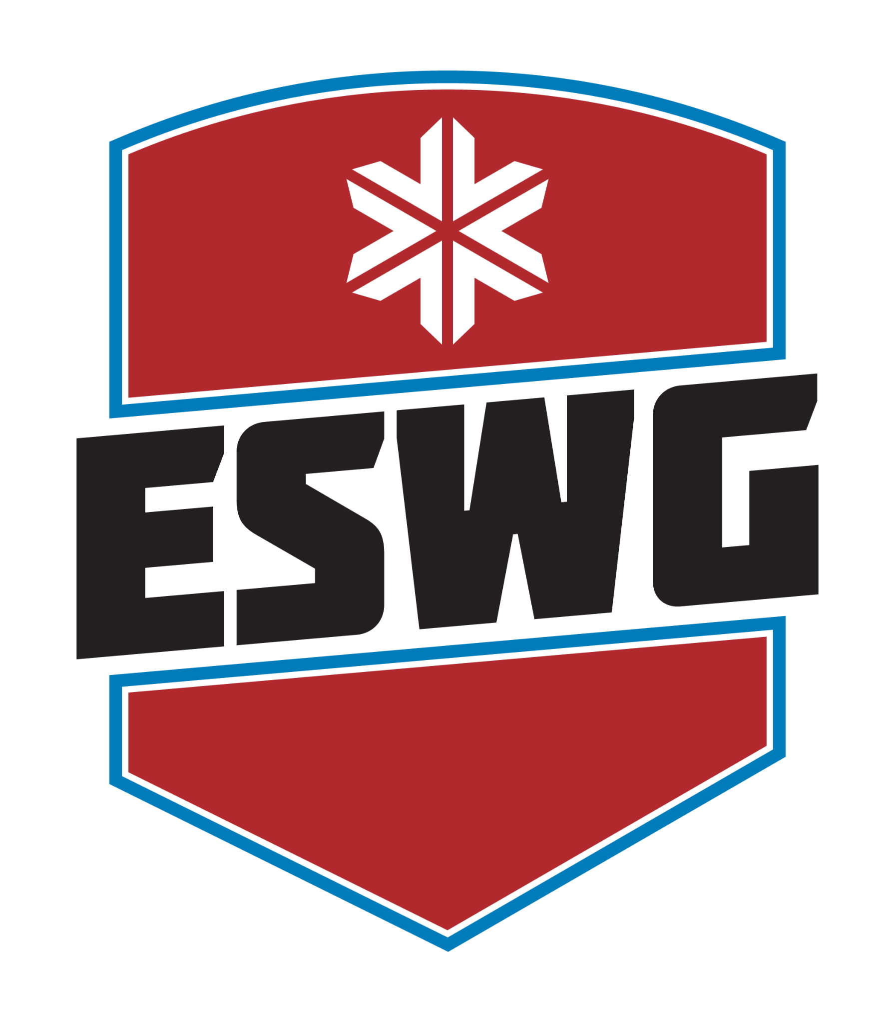

**WAIVER AND MEDICAL RELEASE 2026**

I the undersigned, hereby release and forever discharge any and all rights and claims for damages, including any claims, for loss, damages or injury to my person or property arising out of the performance or failure of performance of the Town of North Elba, Village of Lake Placid, Town of Wilmington, Village of Saranac Lake, Town and Village of Tupper Lake, Paul Smith's College, the Olympic Regional Development Authority, the Adirondack Sports Council, New York Ski Educational Foundation, Bike Adirondacks, the owner of the site of regional and/or finals competition I may by competing in, or the respective officers, agents, representatives, successors and/or assignees of the parties named above, from any and all claims, demands and liability of every kind and nature, legal or equitable occasioned by or arising out of my participation in the competition known as the Empire State Winter Games.

I recognize the challenges of the event(s) in which I have chosen to participate and I assume all risks of personal injury or death in connection therewith. I attest that I am sufficiently physically fit to participate safely therein, and that I have not been advised otherwise by a qualified medical person. I hereby consent to allow my picture or likeness to appear in any official documentary, sponsor advertisement or exclusive television coverage of the Empire State Winter Games in any manner incidental to my participation in the Empire State Winter Games and without compensation to me.

It is strongly encouraged that all participants, their family members, officials, volunteers, and vendors be fully vaccinated on or before the dates of the event. Please follow all CDC and NYS COVID-19 guidelines.

I hereby authorize any first aid, medication, medical treatment, or surgery deemed necessary in case of emergency. I also authorize the attending medical person to execute on my behalf any permission forms and other appropriate medical documents on my behalf if I am not immediately available to do so. I understand that I am responsible for any charges incurred by me for medical treatment.

_________________________________________

Athlete Printed Name

________________________________ ______________

Athlete Signature Date